**PROJECT ON AMAZON SALES REPORT**

INTRODUCTION:

The purpose of this project was to analyze the trends in sale for different product categories, sizes based on the quantities sold. This analysis can help in better decision making and highlights potential problems to strategize sales and optimize inventory.

OBJECTIVE:

* For evaluating performance of product categories and sizes in terms of sales quantity
* To identify which products or categories are high in demand and at which period of time.
* To assess low performing segments and suggest improvement measures.

METHODOLOGY:

* Data cleaning and Manipulation with Python:

1. Checked for null values
2. Filled missing values (taking median of column amount)
3. Dropped irrelevant columns
4. Saved the cleaned data

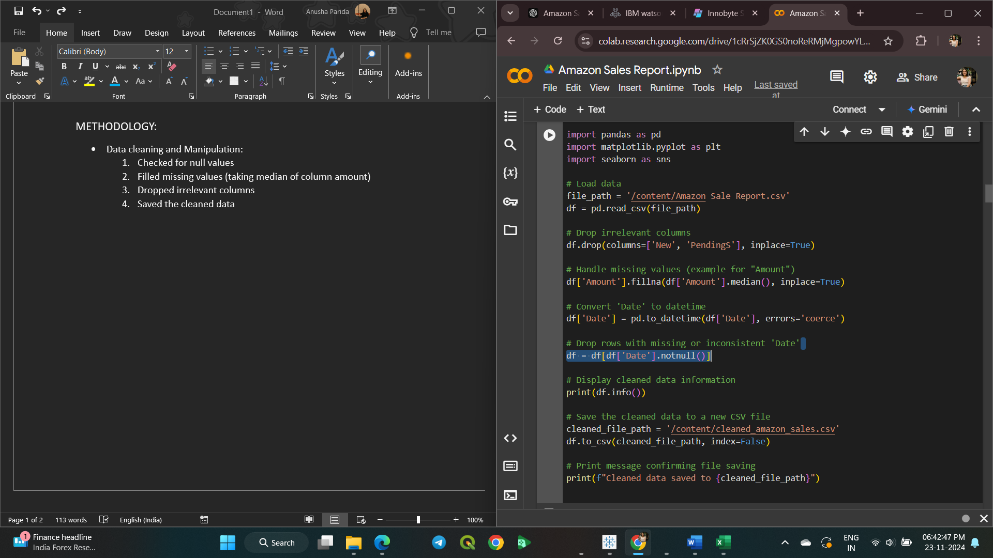

Code Snippet

2. Data Visualization with Tableau

* Sales overview:

The graph represents the **Sales Overview** by product categories over a period of months from March-June,based on the total qunatity sold for each category.

In this sum(quantity sold) is taken to row shelf and date wise month is taken in column shelf.

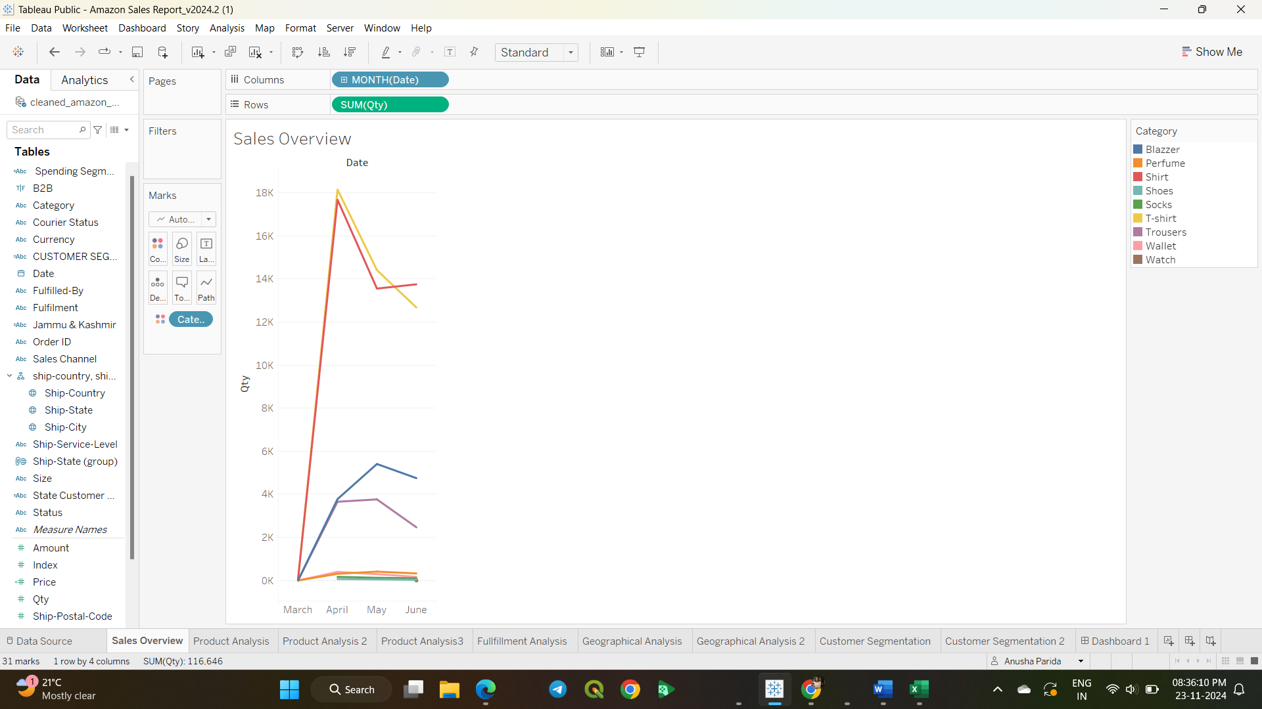

* Product Analysis:

The graphs represent performance of each category based on quantity sold across sizes. It highlights category dominance, size preferences and potential faults in distribution of product.

In this category is taken in row shelf and sum of quantity sold is taken in column shelf with size in color shelf.

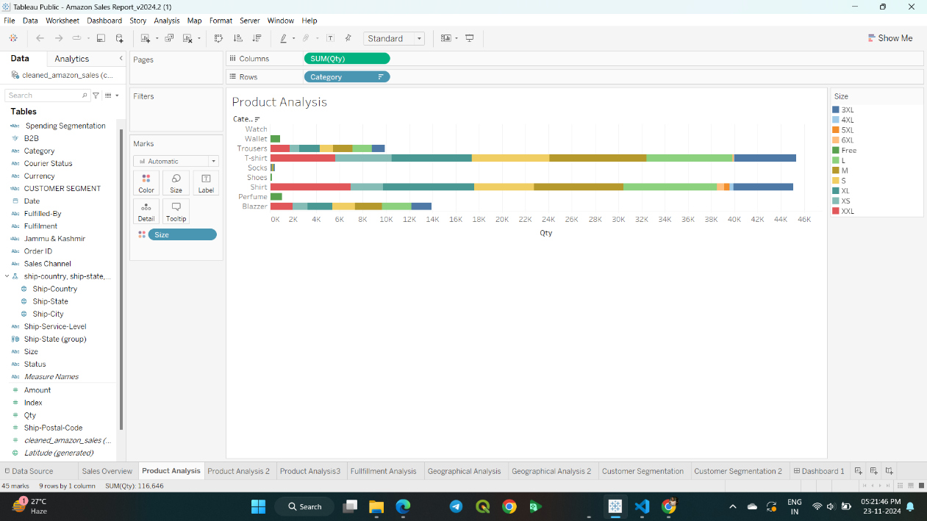

In this category and sum(quantity sold) is taken in columns shelf and size is taken in row shelf.

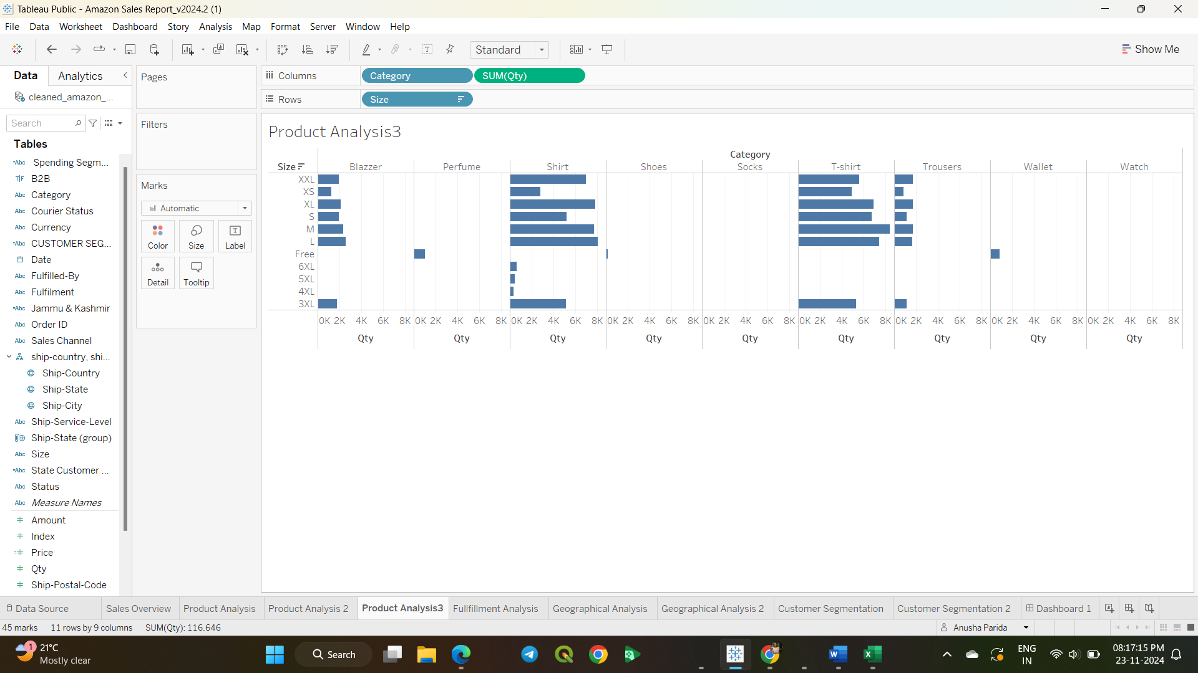

* Fulfillment Analysis:

In this status is taken in color shelf, orderID is taken in text shelf with fulfillment in rows shelf,count(orderID) in column shelf showing the fullfillment success rate.

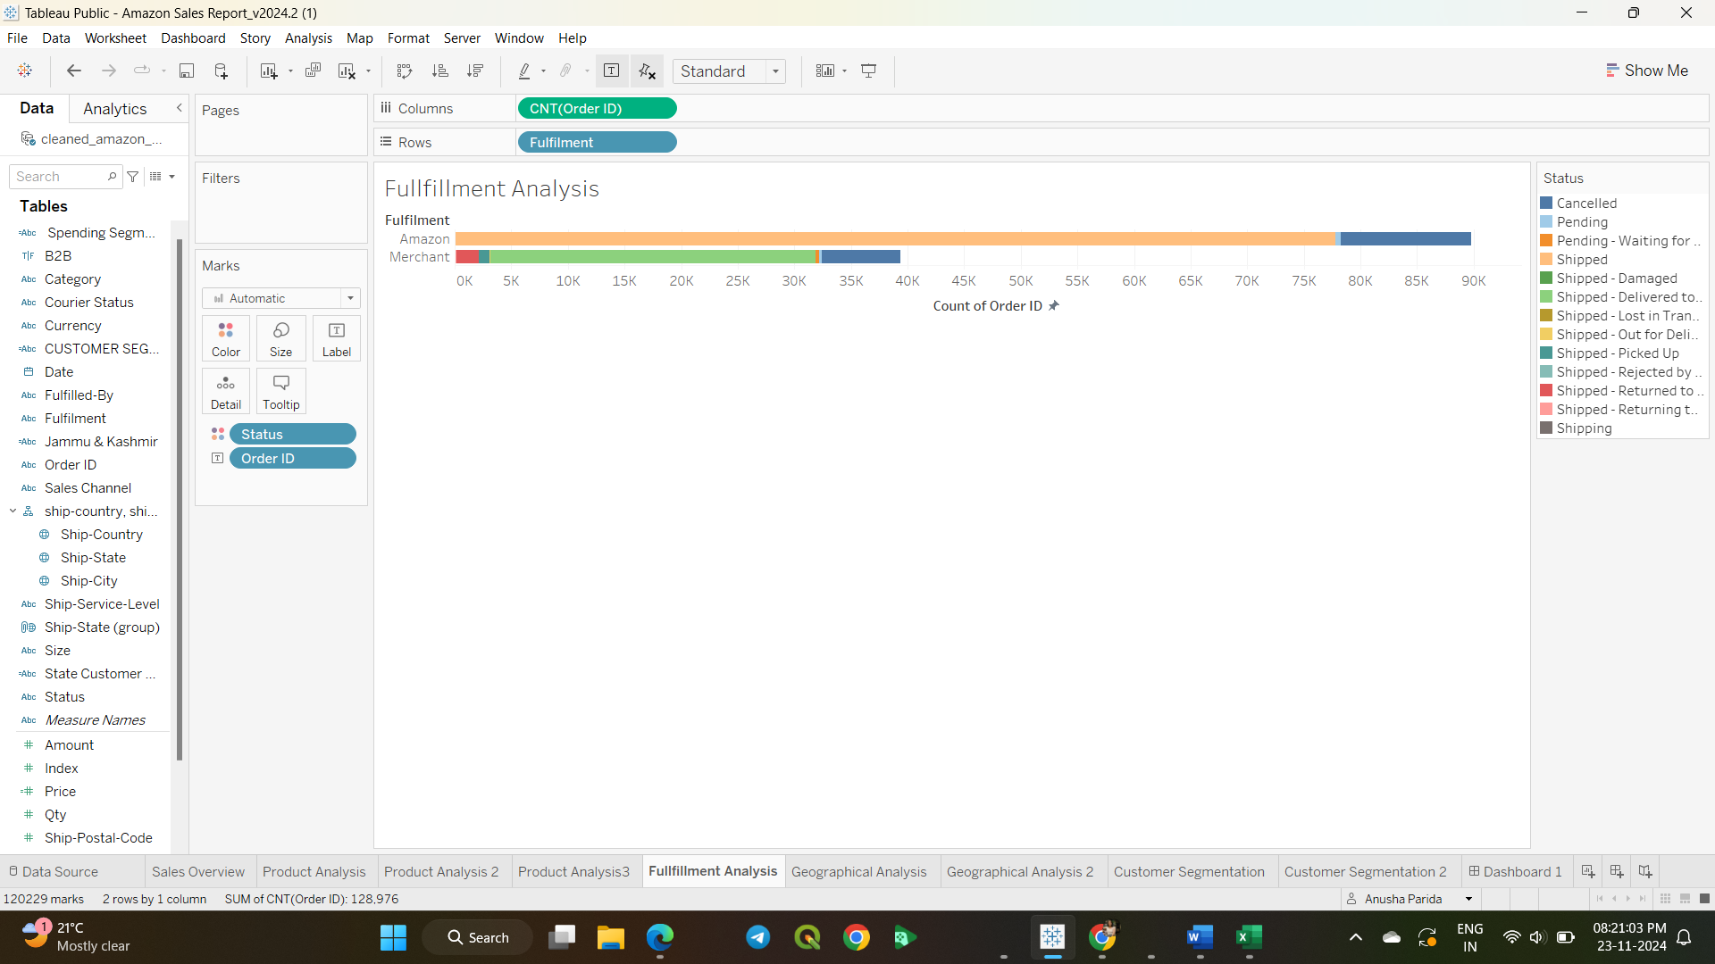

* Geographical Analysis: The graph represents statewise quantity sold.

Here Country,State are dragged to detail, sum aggregate of quantity sold is added to color shelf. The mark is set to map.

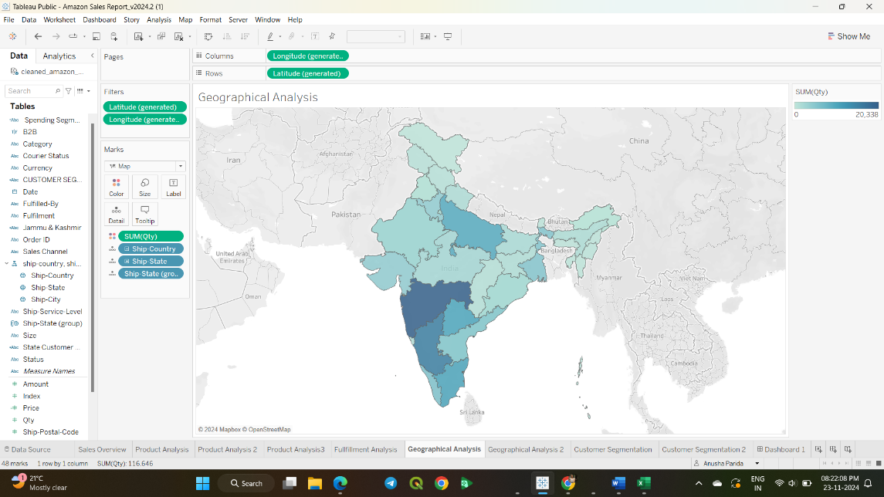

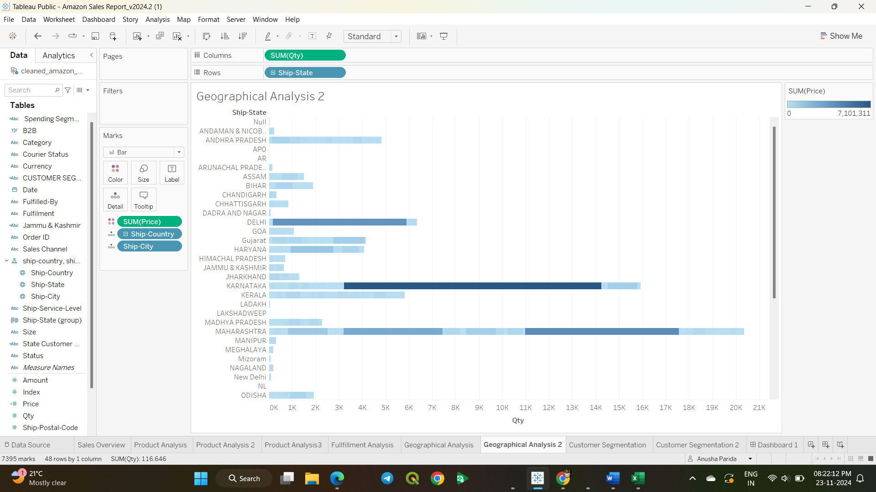

* Customer Segmentation: The graph represents customer behavbiour according to which they are segmented to low, medium and high spender.
  + 1. Low spender:If price spent by customer<=500
    2. Medium spender: If price spent by customer<=1500
    3. High Spender: If price spent by customer>=1500

State-wise geographical analysis:

* + 1. Low spender:If price spent by customer<=500
    2. Medium spender: If price spent by customer is b/w 500 to 15000
    3. High Spender: If price spent by customer>=15000.

In this customer segment is dragged to columns shelf, Count(OrderID) and Sum(Price) is taken to row shelf adding customer segment to color shelf.

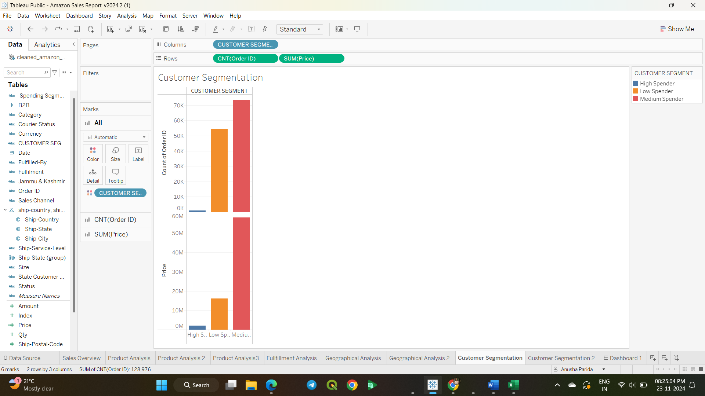

In this mark is set to map, country and state in detail shelf with state wise customer distribution in color shelf.

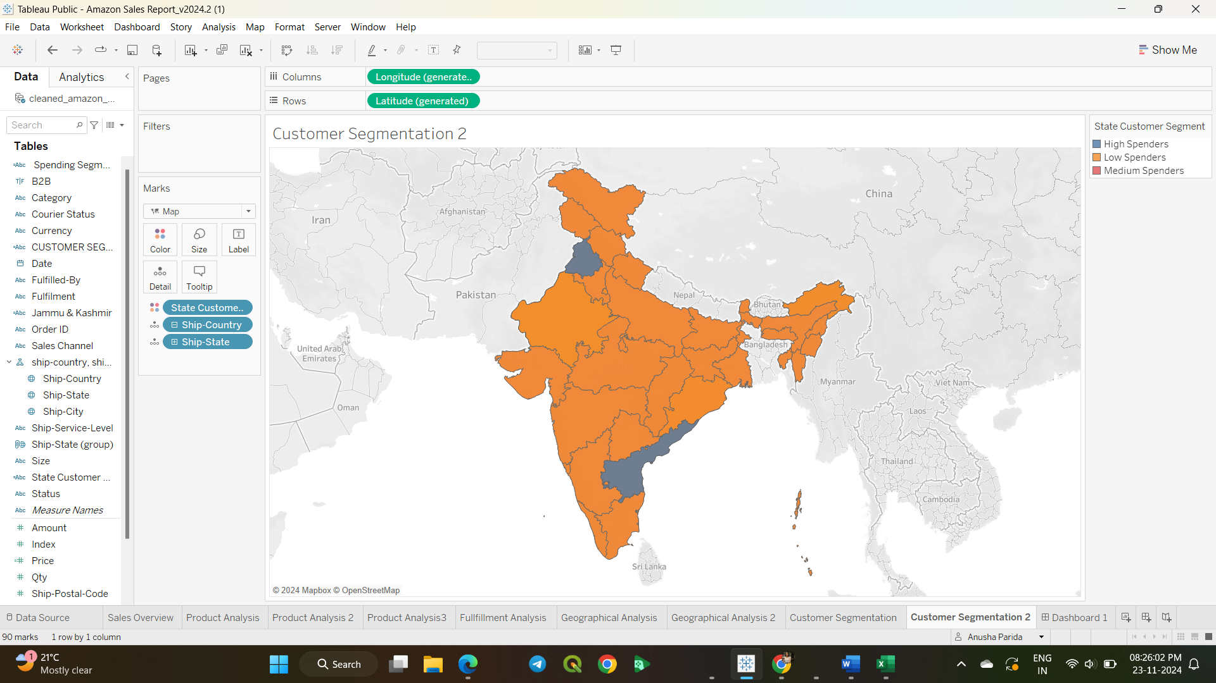

**KEY FINDINGS and RECOMMENDATIONS:**

* Sales overview:

Key Findings: From the analysis it is clearly evident that the tshirts and shirts category items are sold at higher quantities and peak month is generally in April from March-June.

* + 1. There is dominance of T-shirts and shirts which are contributing significantly to the overall revenue.
    2. Moderate performing categories are blazerss or trousers showing minor peak sale in May.
    3. Low performing categories are socks,watch,perfume indicating less popularity or demand. Green line socks showing negligible sale throughout the period.
    4. Sales of most categories peak during April showing possible seasonality trend.
    5. Shoes and socks show a flat trend implying lack of fluctuations in sales.

Recommendation:

* + 1. To increase marketing for T-shirts to maximize revenue.
    2. To explore strategies to replicate success of T-shirts for socks and shoes.
    3. Investigate the cause of underperforming categories.
    4. Plan ahead to increase stocks and run campaigns for April like peak sales.
    5. Identify underperforming products appeal to niche customer segments to boost their sales by taregeted campaigns,sales or discounts.
* Product Analysis:

Key Findings:

* + 1. T-shirts and Shirts lead in sales volume being in the popular category indicating strong customer demand across multiple sizes making them a crucial focus for sales strategies.
    2. Moderate performers: Blazers and perfumes show moderate sales volume but outperforms wallets and trousers. These categories represent stable revenue which can be leveraged for further growth.
    3. Socks being a stable product shows lower sales as well as shoes indicating minimal interest of customers.
    4. Large(L),Medium(M),Extra-Large(XL) sizes dominate sales across multiple categories. There is minimal preference of 3XL,4XL,5XL and XS sizes among consumers. Free size category exhibits moderate sales potentially driven due wallets or perfumes.

Recommedation:

* + 1. Increase sale of T-shirts in M,L,XL sizes to meet demand.
    2. Add new designs and provide seasonal collections to maitain customer interest.
    3. For wallets,shoes and watch there should be promotional discounts to amplify sales.
    4. Higlight wallets and trousers in cross category promotion with T-shirts and Shirts to increase visibility.
    5. Re-evaluate sale performance of socks,perfume whether there is less demand because of lack of visibility,market mismatch or pricing.
    6. Provide flash sales for low performing categories.
* Fulfillment Analysis:

Key Findings:

* + 1. A majority of orders show a "Shipped" status, indicating successful fulfillment.
    2. There is are a number of orders under "Pending" and "Cancelled" statuses, which highlights issues that require attention.
    3. Orders which are fulfilled through Amazon exhibits a higher volume of "Shipped" statuses as compared to Merchant fulfillment.
    4. Merchant fulfillment shows a higher proportion of "Cancelled" or "Pending" orders, suggesting potential gaps.
    5. "Shipped - Damaged" and "Shipped - Lost in Transit" indicate issues with logistics that may affect customer satisfaction.

Recommendations:

* + 1. Investigating the reasons behind high "Pending" orders in both channels like Merchant and Amazon.
    2. Look for ways to improve coordination between pickup teams and warehouses to reduce delays.
    3. To analyze cancellation reasons and implement to reduce them.
    4. To set performance benchmarks to ensure alignment with Amazon's standards.
    5. Collaborate with other courier partners to reduce "Lost in Transit" and "Damaged" shipments.
* Geographical Analysis:

Key Findings:

* + 1. States with darker shades, such as Karnataka and Maharastra, show the highest sales quantities indicating strong customer demand in these regions.
    2. States like Tamil Nadu, Uttar Pradesh, and West Bengal have moderate sales, indicating opportunities for growth by enhanced logistics.
    3. States in the northern and northeastern parts of India, such as Jammu & Kashmir, Himachal Pradesh show significantly lower sales which might be due to logistical challenges or low demand.
    4. Geographical Disparity:
    5. Southern tates are performing better compared to northern and northeastern regions in terms of sales volumes which indicates regional preferences or accessibility issues.

Recommedation:

**Recommendations**

* + **Focus on Low-Sales Regions** by conducting market research in low sales states to understand constraints such as lack of awareness, affordabilityor relevance of product.
  + Strengthen loyalty of customers in high-performing regions by targeted promotions, discounts and quality assurance.
  + Introduce flash sales, additional products or services to capitalize on the existing demand.
  + Enhance logistics infrastructure in low-performing regions to reduce delivery times and provide customer satisfaction.
  + Provideregional warehouses in strategic locations to reduce costs.
* Customer Segmenation:

Key Findings:

* + 1. Majority of customers fall under this low spending category potentially bulking customer count but not the revenue majority.
    2. Medium spenders represent the mid-tier customers, who show there is potential for upselling with loyalty programs.
    3. High Spenders: Though fewer in number but they contribute significantly to the overall revenue.
    4. Regions with a high density of low spenders may overlap with regions having high population but with lower income levels so marketing here should focus on affordable options for increased sales.
    5. States with medium and high spenders give higher disposable incomes so further expanding services in these areas could yield more revenue.

Recommedation:

* + 1. Introduce budget-friendly options with promotional offers to increase frequency of purchase for low spending customer segment.
    2. Use loyalty programs, discounts on premium products to divert medium spenders towards the high-spender customer category.
    3. Invest in regions having high medium and high spender counts for maximum ROI.
    4. Regularlize analysis of customer segmentation and geographic trends of customer segment base to adapt strategies dynamically.

Dashboard:

